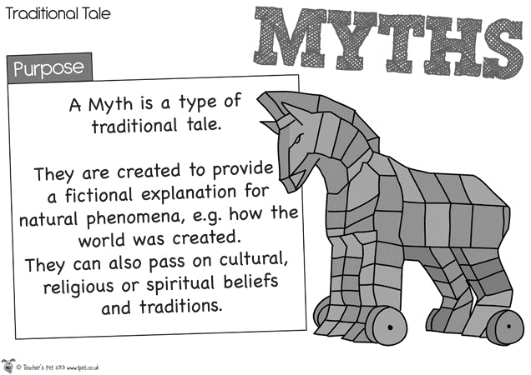
Creation Myth/Origin Myth Assignment
This is an individual assignment. Write your own creation myth/origin myth story. Remember that these stories were intended to explain how things came to be.
In many creation myths, something is created as a solution to a problem. Also, something created is often the result of foolishness on someone’s part.
Choose a setting, characters, etc… then write your myth.
Keep the following elements in mind to explain and include in your myths:
  - Earth (water, land, geographic features)
  - Gods (gods & goddesses)
  - Animals (variation in animals or characteristics)
  - Man (population of earth, different races)
  - Forces of nature (seasons, storms, lightning, volcanoes, snow)

You will be graded on the following criteria:
- Grammar: few to no grammatical errors = 15 points
- Style: writing style is age appropriate, & language is consistent = 20 points
- Story: myth is creative, interesting, & complete = 30 points
- Time on task: time in class is used wisely = 20 points
- Elements: at least 1 of the listed elements is used in the myth = 15 points

